|  |  |  |
| --- | --- | --- |
| Project Settings: <https://drive.google.com/open?id=1bIWSzxDlhNRyUOUX_9wq728ZlzKtD0T2mv1hEl6MYnA>  Please view project settings before start | | |

1. **Task Requirement / Description**
2. **Navigate to Task Area**
3. **UI Example**
4. **Programming Logic**
5. **Database**
6. **Changes to Commit ( developer to complete )**
   1. **Files / Folders to add to live site**
   2. **Database Changes to add to live site**
   3. **Developer notes / instructions for Project Manager**

**1. Task Requirement / Description**

The customer wants to add more information to the 2nd level category page / product page of the wwwclip2 version site.

Please add to the admin site, on the category manager page, an option on the action menu to “Edit Details”. On the details page allow user to upload a product image, and add description text. The description textarea should allow the user to add formation ( wysiwyg editor )

For the front end, on the category level 2 page if details for the product exist under the category title add larger image, then add description under the image ( description text will be on own row that is full with of content area ). And move the pdf and youtube links to right side of image.

**2. Navigate to Task Area**



**3. UI Example**

**ADMIN SITE**

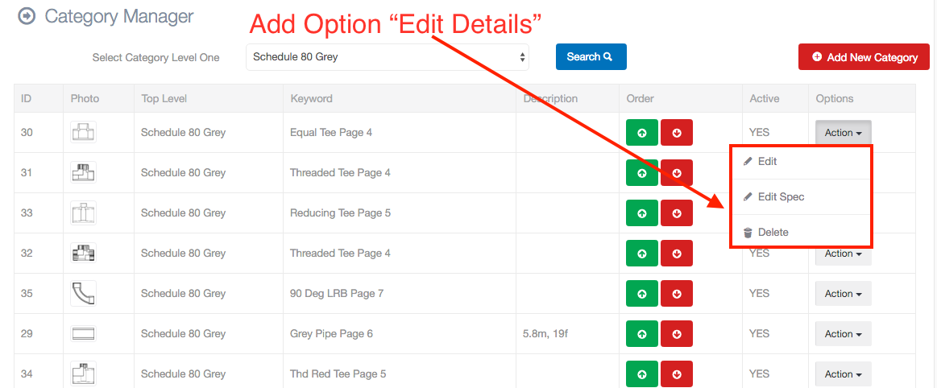  
  
Admin Edit Details Modal

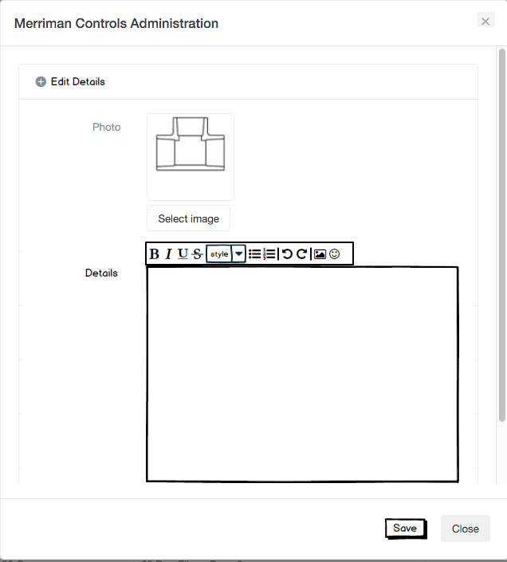

FRONT END

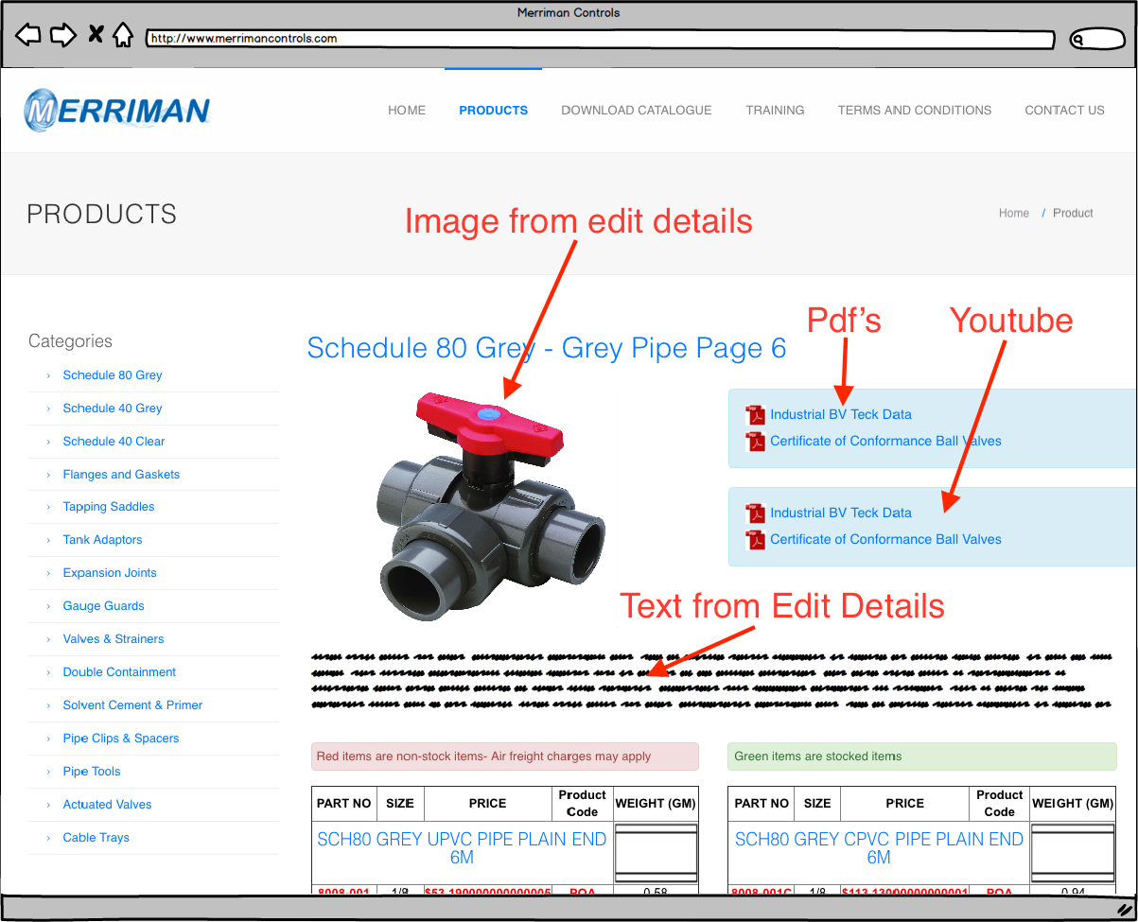

**4. Programming Logic**

ADMIN

1. On user click action menu check if details exist
2. If details exist load into modal and update data
3. If no details exist then show empty modal and insert data

Front End

1. On page load check if details exist for category in categoryDetails
2. If details exist show details same as above
3. If no details exist then show normal page

**5. Database**

Add new table categoryDetails

Add Fields:

* Id (bigint) required - auto_increment
* categoryDetails (text) - required ( wysiwyg text )
* categoryImage (varchar255) - required ( image file name )

**6. Changes to Commit ( Developer to Complete section 6a, 6b, 6c)**

This section is to help the Project Manager update the test site and live site. Please fill in the below area’s 6a, 6b and 6c, this is to inform the Project Manager as to what changes were made and needed to add update the live site

You need to upgrate from SVN

There is a lot of change & add

**6a. Files / Folders to add to live site**

Please add to the below table a list of files or folders that the Project Manager will need to upload to the live site.

|  |  |  |  |
| --- | --- | --- | --- |
| Folder Name: |  | | |
| File Name | File Name | File Name | File Name |
|  |  |  |  |
|  |  |  |  |
|  |  |  |  |

|  |  |  |  |
| --- | --- | --- | --- |
| Folder Name: |  | | |
| File Name | File Name | File Name | File Name |
|  |  |  |  |
|  |  |  |  |
|  |  |  |  |

|  |  |  |  |
| --- | --- | --- | --- |
| Folder Name: |  | | |
| File Name | File Name | File Name | File Name |
|  |  |  |  |
|  |  |  |  |
|  |  |  |  |

**6b. Database Changes to add to live site**

Please add below any db changes or db script code the Project Manager will need to add to the live site database

CREATE TABLE `category_details` (

`id` bigint(20) unsigned NOT NULL AUTO_INCREMENT,

`categoryID` bigint(20) unsigned NOT NULL,

`categoryDetails` longtext COLLATE utf8_bin,

PRIMARY KEY (`id`)

) ENGINE=MyISAM AUTO_INCREMENT=2 DEFAULT CHARSET=utf8 COLLATE=utf8_bin;

**6c. Developer notes / instructions for Project Manager**

Please add here any instructions for the Project Manager to follow for updating the live site

Eg. 1. Please run db script

2. Please insert new data to db

3. Then update files in live site

**END**